Cloudera Installation step by step process :

Step 1.

https://github.com/teamclairvoyant/hadoop-deployment-bash

Step 2.

Login to personal github and fork to personal github

Step 3.

Create folder and dowload https://github.com/teamclairvoyant/hadoop-deployment-bash

Step 4.

Goto folder in terminal ls

Step 5.

To generate hostlist.Evaluation of Hostlist

cat <<EOF >HOSTLIST
ssh ip address
EOF
Step 6.
Evaluation step evaluate-pre for all script file are stored in evaluate folder

mkdir evaluate-pre
for HOST in `cat HOSTLIST`; do
echo "*** $HOST"
scp -p /home/anji/devops/hadoop-deployment-bash-master/evaluate.sh ${HOST}:
ssh -qt $HOST './evaluate.sh' >evaluate-pre/${HOST}.out 2>evaluate-pre/${HOST}.err
done
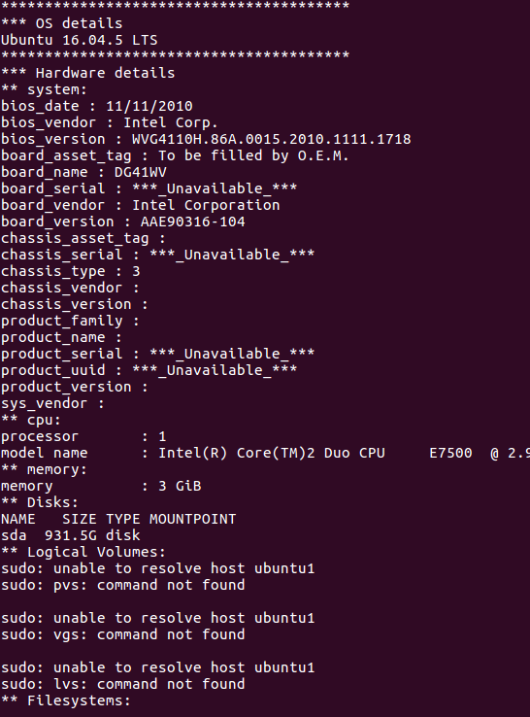

Step7.
Copy several of the scripts to the nodes.

install_tools.sh
change_swappiness.sh
disable_iptables.sh
disable_ipv6.sh
disable_selinux.sh
disable_thp.sh
install_ntp.sh
install_nscd.sh
install_jdk.sh
configure_javahome.sh
install_jce.sh
configure_tuned.sh
install_entropy.sh
install_jdbc.sh

---> it will distribute across listed hosts
for HOST in `cat HOSTLIST`; do
echo "*** $HOST"
scp -p \
/home/anji/devops/hadoop-deployment-bash-master/install_tools.sh \
/home/anji/devops/hadoop-deployment-bash-master/change_swappiness.sh \
$HOST:
done
Run the scripts to prep the systems:

for HOST in `cat HOSTLIST`; do
echo "*** $HOST"
ssh -t $HOST " \
sudo bash $BOPT ./install_tools.sh; \
sudo bash $BOPT ./change_swappiness.sh; \
sudo bash $BOPT ./disable_iptables.sh; \
sudo bash $BOPT ./disable_ipv6.sh; \
sudo bash $BOPT ./disable_selinux.sh; \
sudo bash $BOPT ./disable_thp.sh; \
sudo bash $BOPT ./install_ntp.sh; \
done

cat <<EOF >HOSTLIST
192.168.3.87
administrator@192.168.3.33
EOF
Installing the Cloudera Manager server with the embedded PostgreSQL database.

scp -p /home/anji/devops/hadoop-deployment-bash-master/install_clouderamanagerserver.sh ${CMSERVER}:
ssh -t ${CMSERVER} "sudo bash $BOPT ./install_clouderamanagerserver.sh embedded $CMVER"
Cloudera Manager Dashboard:

localhost:7180

user name : admin
password : admin

Thank you for choosing Cloudera Manager and CDH.
This installer will install Cloudera Enterprise Trial 5.16.1 and enable you to later choose packages for the services below (there may be some license implications).
- Apache Hadoop (Common, HDFS, MapReduce, YARN)
- Apache HBase
- Apache ZooKeeper
- Apache Oozie
- Apache Hive
- Hue (Apache licensed)
- Apache Flume
- Apache Impala
- Apache Sentry
- Apache Sqoop
- Cloudera Search (Apache licensed)
- Apache Spark
You are using Cloudera Manager to install and configure your system. You can learn more about Cloudera Manager by clicking on the Support menu above.

Continue

Specify hosts for your CDH cluster installation.

Hosts should be specified using the same hostname (FQDN) that they will identify themselves with.
Cloudera recommends including Cloudera Manager Server's host. This also enables health monitoring for that host.
Hint: Search for hostnames and IP addresses using patterns.
1 hosts scanned, 1 running SSH.

 | Expanded Query | Hostname (FQDN) | IP Address | Currently Managed | Result
 | 192.168.3.87 | foo-1.example.com | 192.168.3.87 | No | Host ready: 0 ms response time.

Continue

Cluster Installation

Select Repository
Cloudera recommends the use of parcels for installation over packages, because parcels enable Cloudera Manager to easily manage the software on your cluster, automating the deployment and upgrade of service binaries. Electing not to use parcels will require you to manually upgrade packages on all hosts in your cluster when software updates are available, and will prevent you from using Cloudera Manager's rolling upgrade capabilities.
Use Packages
Use Parcels (Recommended)
CDH-5.16.1-1.cdh5.16.1.p0.3
CDH-4.7.1-1.cdh4.7.1.p0.47
Versions of CDH that are too new for this version of Cloudera Manager (5.16.1) will not be shown.
ACCUMULO-1.7.2-5.5.0.ACCUMULO5.5.0.p0.8
ACCUMULO-1.4.4-1.cdh4.5.0.p0.65
None

IMPALA-2.1.0-1.impala2.0.0.p0.1995
None

KAFKA-3.1.1-1.3.1.1.p0.2
None

KUDU-1.4.0-1.cdh5.12.2.p0.8
None

SOLR-1.3.0-1.cdh4.5.0.p0.9
None

SPARK-0.9.0-1.cdh4.6.0.p0.98
None

SQOOP_NETEZZA_CONNECTOR-1.5.1c5
None

SQOOP_TERADATA_CONNECTOR-1.7c5
None

Matched release for this Cloudera Manager Server
Custom Repository
Example for SLES, Redhat or other RPM based distributions:
https://archive.cloudera.com/cm5/redhat/6/x86_64/cm/RPM-GPG-KEY-cloudera
Example for Ubuntu or other Debian based distributions:
https://archive.cloudera.com/cm5/debian/squeeze/amd64/cm/archive.key

Continue

Click on continue till 7th step ..

Your cluster will be up an ready

